Insight: December 2023

  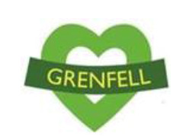
  

Insight

North Kensington update. A bulletin where we share the learning and insight from the North Kensington Recovery Programme (Grenfell).

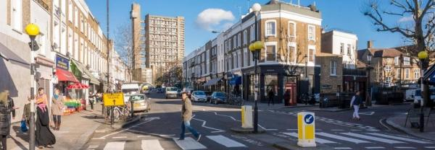


Hello,
The end of the year provides an opportunity to reflect on the past and look ahead to the future.
As ever, our thoughts are with the families of everyone who lost their lives that night. They will always be remembered.
Over the last year we have been privy and privileged to hold many conversations with the community. Especially important were the ones held with Survivors and Bereaved, as well as our Health Partners. Collectively they helped to inform both our Health & Wellbeing Strategy refresh and the Grenfell Joint Strategic Needs Assessment (JSNA), which will be published in the New Year.
A reoccurring theme throughout the year was the continuing impact on those living closest to the Tower in Grenfell Walk and the Lancaster West housing estate. Back in September 2023, Rob Hurd, Chief Executive of NHS North West London and James Benson, Chief Executive of Central London Community Healthcare NHS Trust accompanied me to a community meeting at Lancaster West to listen to their concerns.
We feel honoured to now be tasked with starting our commitment to shaping the health services and support that will be put in place for the next five years and beyond. This starts with more conversations in the New Year. These conversations also have a clear purpose, being connected to a community-led recovery which will be designed, with your help.
We look forward to shaping a future health service that meets everyone’s needs and so value hearing from all demographics and all age groups, especially children and young people. Although everyone’s voice is important, we especially want to hear from those whose voices we haven’t yet heard. We promise to listen.
Please look out for our invitation to attend the events being held at venues local to you. We really appreciate that some of our valued partners will be hosting these events and you can view more detailed information below.
Just a reminder that you can find details of all the services that are available to you here. If you want to follow up with any member of my team, the easiest way to reach us is by emailing directly at: nhsnwl.nkrt@nhs.net
Whether you’re home, or away, I wish you and your loved ones a peaceful festive break.
Best wishes,
Mike Martin
Assistant Director, North Kensington Recovery Team



NKR programme: our plan for co-design
In early 2024 the North Kensington Recovery (NKR) programme plans to work together with local communities and partners, to jointly determine what future health services and support should look like for those affected by the Grenfell Tower Fire.
This will build on the feedback and wide range of views already expressed by North Kensington residents on the health needs arising from the Grenfell Tower Fire.
However, this is more than just asking for experiences on how current services are operating. The design process will consider how the quality, safety and equity of care provided to patients, families and carers can improve – and changes may be made to future services as part of the design process.
We will publish documents soon that will provide further details. These will be available in translation format, so that every local resident and partner has the same understanding of what this work entails, what it aims to achieve and how the outcomes of this joint work will benefit every local resident whose life was changed forever following the tragedy that took place on 14 June, 2017.

Grenfell Testimony Week
Grenfell Testimony Week will take place on 23-26 January 2024 at Church House in Westminster, central London.
Testimony week is a platform for those affected by the Grenfell Tower Fire in 2017 who wish to speak about the impact it has had on them and those they care about. The shape and content of the event is being driven by the people participating. This will include live spoken testimony, pre-recorded contributions, written statements, and other contributions such as artworks. The event will not be subject to the same restrictions as a formal legal process.
More details are available here.

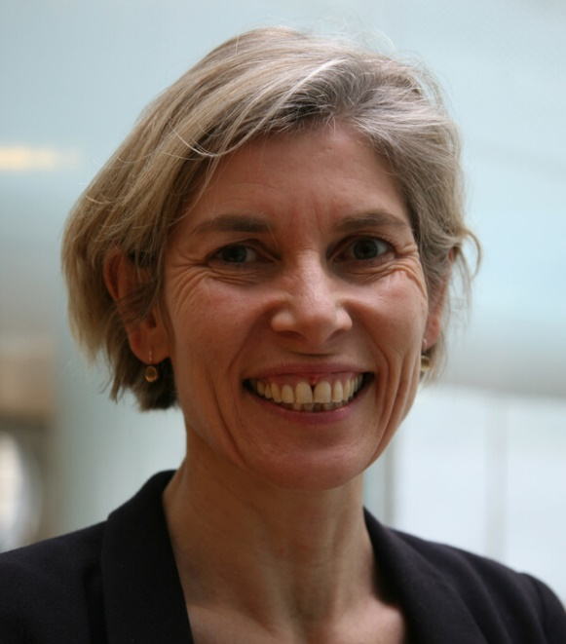

North West London Integrated System update
The November 2023 issue of the North West London Integrated System update has been published. Aimed at partners across North West London, it provides a comprehensive update that covers programme and service developments at both a North West London and borough level.
Penny Dash (pictured above), our Chair of the North West London Integrated Care System (NW London ICS), has written a blog that proposes big changes are needed if we want better health care and also details the challenges that lie ahead.

Junior doctors strike
Junior doctors will be on strike from 7am, 20 December - 7am, 23 December 2023 and from 7am, 3 January - 7am, 9 January 2024.
Services are expected to be very busy and although most GP surgeries will remain open, if you have any health concerns that can’t be resolved by your local pharmacist then call NHS 111, or access their service online. Full signposting advice is available on our main website.



Draft mental health strategy: share your views
We are developing our overall plan for mental health services in North West London. We would very much welcome views of the public on our draft strategy, which is now published.
This draft strategy is very much a work in progress that has been developed through a series of discussions and public events across our eight boroughs. A final version of the strategy is expected to be published in early 2024.
If you would like to get involved and input to our plan, two further online events have been planned on 11 and 16 January 2024. Details will be confirmed soon. You can also email nhsnwl.communications.nwl@nhs.net with any comments or queries.



NHS North West London hosts library drop-ins
NHS North West London will be visiting libraries in Westminster and Kensington and Chelsea over the few months with local residents invited to drop-in and ask questions and hear about what is happening about local health services, including the acute mental health consultation that is currently underway.
The drop-ins are open to every resident and will take place in the North Kensington area on 15, 17 and 23 January 2024. Further details are available here and we look forward to welcoming you.

Palliative care update
North West London residents are currently being asked to provide feedback on potential service options for delivery of the new model of care for adult (18+) community-based specialist palliative care.
A series of webinars have been held at both a NW London and borough level to discuss the potential options, where local residents have been able to provide feedback, ask questions and make suggestions of their own. People are also able to provide feedback via a simple survey.

Primary care



Pop up clinics and health checks available at community venues
Our Neo Health vaccine pop-up held recently at Lancaster West was well attended, with many people not only receiving their vaccinations but also being receptive to booking other health checks. More vaccine pop-up clinics will be provided in early 2024 at various community venues.
Grenfell-affected patients are also eligible for a free Enhanced Health Check. These ‘health assessments’ are a great way of keeping you and your family healthy.
You can book these via your GP, at a local community venue. Further details are available here and we will bring you more news about how families can access them in the New Year.

Flu cases on the rise - protect yourself and others
All those eligible for the flu vaccine are being urged to come forward as the UK Health Security Agency (UKHSA) has published data showing a significant increase in the number of recorded flu cases.
The NHS national booking system is closed, but eligible persons can still continue to speak to their GP, or alternatively a local pharmacist about getting their vaccination.
Additionally, a team of experts at Imperial College Healthcare NHS Trust have developed a resource pack to help parents who may be concerned about their child's health. It will help parents to identify when an illness is minor and when it is serious. Click here to download the booklet.

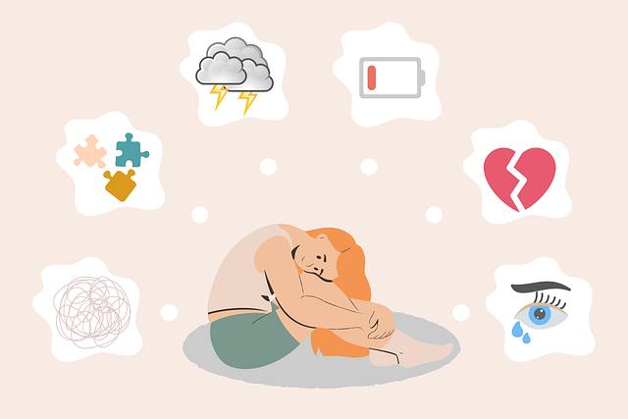

Talking therapies
As the year draws to a close it is not uncommon to experience difficult emotions such as low mood, anxiety, stress. Talking to someone in a safe, confidential space about how you are feeling can sometimes help.
'Talking therapies’ can help you to learn ways to improve your emotional wellbeing, have the space to think about your difficulties and find ways to manage them better.
Talking therapies are available for anyone aged 16 and over and who is registered with a GP in Kensington and Chelsea, Queen’s Park and Paddington. You can either ask your GP to refer you or it is quick and easy to self-refer online by completing this form.
A member of our team will be in touch within 5 working days once we’ve received your form to arrange an initial chat. For more information, visit the Community Living Well website.



Winter wellness - support is available
We appreciate that although the festive season can be a time of joy, especially if the break allows you to connect with loved ones, for some people their feelings of sadness and loss can be heightened. Staying at home during the winter months may also contribute to intense anxiety over the rising cost of household bills.
There are many local venues that are open and are great places to stay warm and access support. Some of our Health Partners and Healthier Futures partner venues are also open and will offer a warm welcome if you fancy a change of scene.

Health Partners

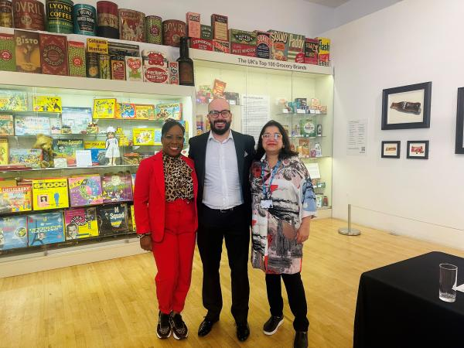

Expressing our appreciation
We would like to express our thanks and appreciation to our Health Partners, who have supported the community in leading many of our conversations over the last few years.
In 2024 they will not only host meetings to shape the co-design but have an integral role in working closely with their service users to ensure there is input from community members to shape NHS services – and that this input is accessible, relevant and inclusive.
With some people travelling overseas to visit loved ones, our wish is for a peaceful end to what’s been a busy year. In our next bulletins our case studies will focus on the work of Hear Women, Baraka and many others.
Image: Camille, Mike and Radhika from the NKR team

Healthier Futures

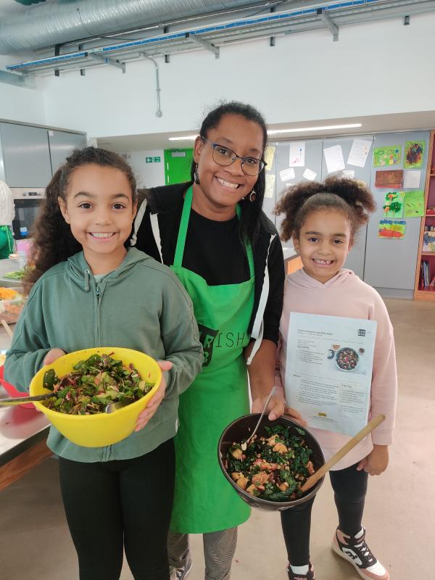

Cultivate Create: a fruitful harvest
Cultivate Create is ACAVA's fun creative gardening project for North Kensington families of all ages. One morning over the October half-term, families met at the garden kitchen at Maxilla Walk Studios to harvest over 12 types of veggies grown over the season.
With help from the Nourish Hub, a local community kitchen focused on environmental sustainability and food waste reduction, they cooked their produce (see image), whilst learning about nutrition and minimising food waste, and then sat together to share a delicious meal.
To wrap up the year, families spent a day in the recently restored Fulham Palace Gardens, one of the most important botanical gardens since the 16th century and the second oldest in London. During the day, the Palace's learning team gave the group a tour of the site, led a special gardening session and organised a festive creative craft workshop.
Learn more about Cultivate Create and the Nourish Hub.

Unsubscribe
This email was sent by NHS North West London. Why did I get this?
© 2023 NHS North West London. 15 Marylebone Road London NW1 5JD

